Evaluation of Equivalent Erlang Telephony

Aswathi Saminathan
Master of Science in Telecommunications
University of Pittsburgh
Pittsburgh, United States
ASS86@pitt.edu
Snehal Kalam
Master of Science in Telecommunications
University of Pittsburgh
Pittsburgh, United States
SNK33@pitt.edu

Hardik Ashar
Master of Science in Telecommunications
University of Pittsburgh
Pittsburgh, United States
HNA5@pitt.edu

Abstract— Erlang formulas are generally applicable for circuit switched networks. In general, Erlang-B formulas deals with data loss in relation with the traffic load. This work is concerning the modelling of the regular IP traffic into Equivalent Erlang traffic and the applicability of the loss formula for the IP traffic. In the real world, IP networks are asynchronous in nature. Thereby, there is possibility of utilising Erlang formulas for asynchronous networks based on the common properties of the synchronous and asynchronous networks. The traffic of the asynchronous network is defined using loss, link utilisation and bandwidth. The results for these parameters are obtained using MATLAB that depicts the dependency between each parameter. In addition, an online Erlang calculator that uses the Westbay traffic estimator, which has capabilities of varying link characteristics that includes codec and network link that are used. The output of the simulated and the experimental results fitted against probability of packet loss and traffic load Erlangs are plotted

Index Terms—Erlang, IP traffic, packet loss, traffic calculator, bandwidth.

Introduction
There is a rapid growth in the popularity and fast evolution of telecommunication networks since the past few centuries. With constantly rising networking structure leading to higher number of networks and rising traffic load increased the capacity requirements in telecommunication networks. Wrong estimation of expected traffic would lead to economic problems related to return on investments. Therefore, it became important to research on the analysis of dependencies of telecommunication traffic.
Since, real world networks are generally asynchronous networks, attention is given to the description of traffic in such networks. Many of such descriptions are complex with high computational requirements. The use of Erlang formulas can be very efficient and simple to describe traffic parameters.
As we know, Erlang is a unit of telecommunications traffic measurement. One Erlang corresponds to one ongoing call or one occupied channel. Characterized by call arrival rate and call holding time and hence can be calculated as,
a = λ * t _{h}
Erlang formula focus on two models mainly for call loss or call waiting probability calculations which are referred to as Erlang B and Erlang C formulas.
In context of asynchronous networks, these formulas put together link utilization, bandwidth and the probability of packets not being processed immediately on their arrival. The first Erlang formula covers the problem of sufficient trunk lines capacity. These parameters are important from Quality of Service point of view. Hence, they are useful fir asynchronous networks.
This paper proposes the idea of utilization of Erlang B and Erlang C formulas for description of regular IP traffic in Asynchronous networks. The variation of each individual parameters of the formula is modelled and the results are obtained. The values of probability of blocking and the probability of delay were estimated
This paper is organized as follows. Section 2 defines Erlang B and Erlang C formulas. Section 3 provides results obtained through MATLAB simulation and calculations by varying various parameters and plotting respective graphs. The last section derives the conclusion obtained.

ERLANG FORMULAS
Erlang B and C formulas are used to describe traffic in asynchronous networks. Calculations were performed in MATLAB.

Erlang B formulas
Erlang B formula represents the loss rate of packets in asynchronous networks. It is defined as follows:
B=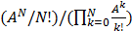 (1)

Where,
B is Loss rate of packets,
A is the offered traffic and
N is the bandwidth.

Erlang B formula can also be written as:

B=1/ (1+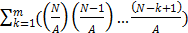 (2)

The use of second formula can significantly decrease the computational requirements and we can also calculate the load of the system with the higher values [1-2].
The following conditions must be met for the first Erlang formula:
- The packet arrival rates originate randomly with exponential distribution, which means higher distance between arriving packets leads to lower number of these cases.
- Service time has similar distribution, i.e. exponential decreasing of packets with higher service time.
- The flow of packets is steady, as if it comes from infinite traffic source.
- Dropped packets do not return to incoming flow, therefore there are not repeated packets.
- No two arriving packets will originate together.

The Erlang B formula has a biggest disadvantage that it assumes no waiting in the queue i.e. if the buffer is full, then the packets are dropped simply. Hence, we make use of Erlang C formula.

Erlang C formulas
The Erlang C formula calculates the probability of waiting. This formula overcomes the disadvantage of B formula by assuming infinite traffic source. The incoming packets are put in queue if the buffer is fully occupied. The formula is as follows:
C = 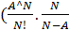)/(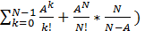 (3)
Where C is Probability of Delay, A is link utilization and N is bandwidth.
This can be written in terms of Erlang B formula by dividing the numerator and denominator by

(4)

Hence, we get

C (5)

Common characteristics of Synchronous and Asynchronous Networks
Erlang formulas were indented for synchronous networks, but here we implement these formulas for asynchronous networks.

EXPERIMENTAL RESULTS
This section describes the simulation based results obtained by calculations using Erlang B formula. The variation of input parameters was tested as follows:
- One of the parameter was kept constant
- Other parameter was incremented in a step sequence
It is possible to perform calculation of loss B through Erlang B formula having the value of link utilization [A] and bandwidth. In addition, it is possible to estimate link utilization [A] using the method of bisection, provided values of bandwidth N and loss B are given [3].

Bandwidth and Loss in the case of constant Link Utilization
The performance measurement was tested for Loss [B] from the Erlang B formula incrementing Bandwidth [N] in steps. In this scenario, varying values of link utilization [A] is used. With different values of Link Utilization [A] the response was measured and the following observations were made as in [4].
With increasing the value of Bandwidth[N], the loss [B] reduces. In addition, for a higher bandwidth [N] with more utilization [A] the value of loss is more compared to the loss at lower at a lower utilization rate. Fig 1 depicts this relation between the parameters.

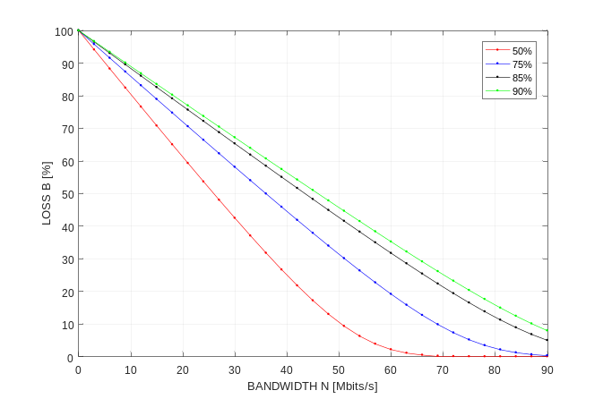
Fig 1: Dependency between loss and bandwidth in the cases of constant utilization

Loss and Link Utilization in the case of Constant Bandwidth
The performance measurement was tested for Loss [B] from the Erlang B formula incrementing Link Utilization [A] in steps. In this scenario, varying values of Bandwidth [N] is used. With different values of Bandwidth [N] the response was measured and the following observations were made.
With increasing the value of Link Utilization [A], the loss [B] increases. In addition, for a higher bandwidth [N] with more utilization [A] the value of loss is less compared to the loss at lower at a lower utilization rate and lesser bandwidth. Fig 2 depicts this relation between the parameters.
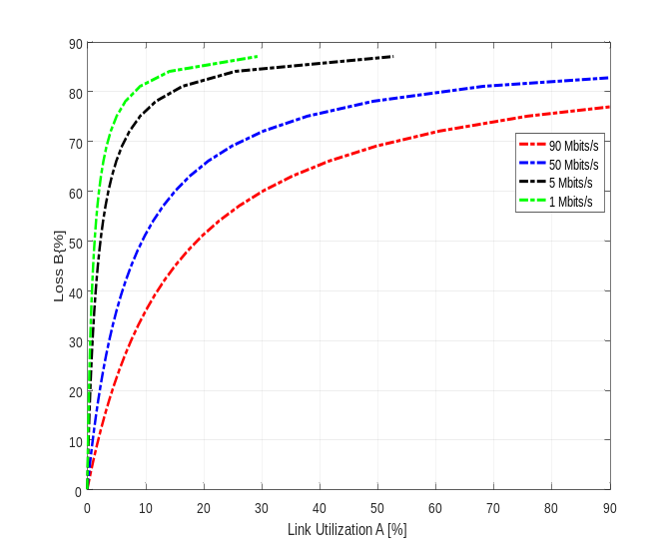
Fig 3: Probability of delay in the case of constant bandwidth and increasing link utilization

Owing to the serious drawback of Erlang B formula with no space for waiting in the queue the packets are dropped instead of waiting in the queue. The phenomenon of probability of waiting is achieved by using Erlang C formula. This formula assumes waiting in the queue thus the packets rather than being dropped are just delayed.
The results with the use of these formula are in the following discussions. The probability of delay [C] is estimated with the use of Erlang C formula. The formula in addition holds use of the bandwidth [N] and link utilization [A].

Link Utilization and Bandwidth in the case of constant Probability of Delay
The probability of delay is simulated using the Erlang C formula by increasing the value of Link Utilization [A], the probability of delay [C] variation is observed having constant values for bandwidth. It is observed that as the value of bandwidth increases the delay probability decreases for higher utilization [A]. The response for this is plotted as shown in Fig 3
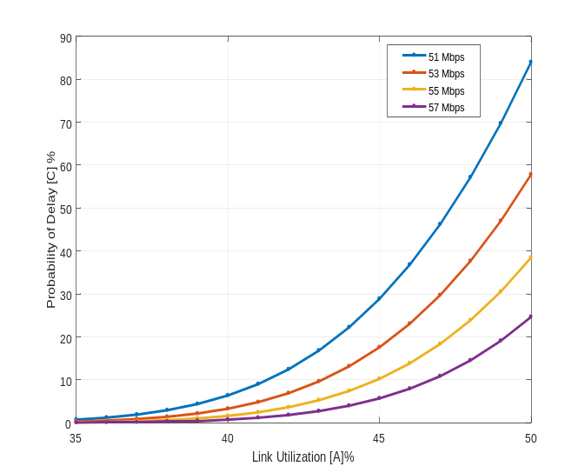Fig 2: Dependency between loss and link utilization in the case of constant bandwidth

Link Utilization [A] and Bandwidth [N] in the case of Constant Probability of Delay [C]
The dependency between Bandwidth [N] and Link Utilization [A] is observed fixing the values for different values of delay for placing the packets in queue, when the delay is high the link is utilized to a maximum limit. The link utilization is depicted as shown in Fig 4
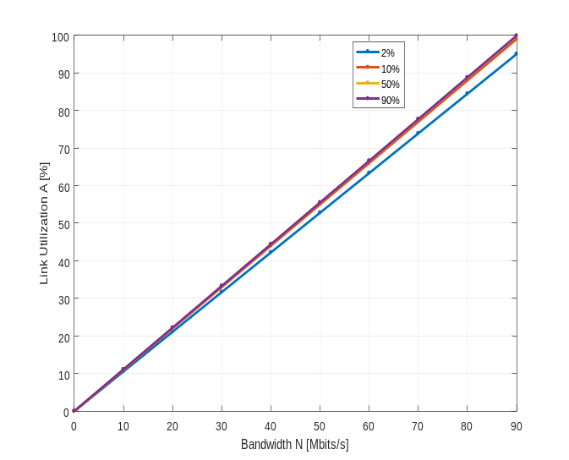
Fig 4: Link utilization in the case of constant probability of delay and increasing bandwidth
The obtained results as shown in the above figures are correlated and the following conclusions are made

- In the case of constant bandwidth N together with increasing link utilization A the loss B and probability of delay C are increasing.
- In the case of constant link utilization, A together with increasing bandwidth N the loss B and probability of delay C are decreasing.
- In the case of increasing link utilization, A together with decreasing bandwidth N the loss B and probability of delay C are increasing.

Simulation result discussion
An online calculator that was obtained from Westbay Erlang Calculator organisation was used for performing the simulation was performed for infinite traffic sources using Erlang B model. The traffic arrival rate was varied and the corresponding Erlang traffic was specified after the input values were given the corresponding probability of block was modelled. This traffic was calculated for an average of 30seconds and 60 seconds. These results were in turn compared to the calculated values using the Erlang B and Erlang C formulas.
The results are tabulated and the corresponding graphs depicting the relationship is discussed.
- AVERAGE FLOW RATE 30Sec
Call arrival  rate  [calls/sec] | Traffic  load A  [Erl] | Calculated  packet loss  PB’ [%] | Measured  packet loss  PB’ [%]
0.02 | 0.6 | 0.25112 | 0.10112
0.04 | 1.2 | 0.39658 | 0.24658
0.06 | 1.8 | 0.51652 | 0.36652
0.08 | 2.4 | 0.6086 | 0.4586
0.1 | 3 | 0.67941 | 0.52941
0.12 | 3.6 | 0.73484 | 0.58484
0.14 | 4.2 | 0.7791 | 0.6291
0.16 | 4.8 | 0.81513 | 0.66513
0.18 | 5.4 | 0.84495 | 0.69495
0.2 | 6 | 0.87 | 0.72
0.22 | 6.6 | 0.89132 | 0.74132
0.24 | 7.2 | 0.90967 | 0.75967
0.26 | 7.8 | 0.92562 | 0.77562
0.28 | 8.4 | 0.93962 | 0.78962
0.3 | 9 | 0.95198 | 0.80198
0.32 | 9.6 | 0.96299 | 0.81299
0.34 | 10.2 | 0.97284 | 0.82284
0.36 | 10.8 | 0.98172 | 0.83172
0.38 | 11.4 | 0.98975 | 0.83975
0.4 | 12 | 0.99706 | 0.84706
0.42 | 12.6 | 1.00373 | 0.85373
0.44 | 13.2 | 1.00985 | 0.85985
0.46 | 13.8 | 1.01548 | 0.86548
0.48 | 14.4 | 1.02068 | 0.87068
0.5 | 15 | 1.02549 | 0.87549
0.52 | 15.6 | 1.02995 | 0.87995
0.54 | 16.2 | 1.03411 | 0.88411
0.56 | 16.8 | 1.03799 | 0.88799
0.58 | 17.4 | 1.04162 | 0.89162

- AVERAGE FLOW RATE 60SEC
Call arrival  rate  [calls/sec] | Traffic  load A  [Erl] | Calculated  packet loss  PB’ [%] | Measured  packet loss  PB’ [%]
0.02 | 0.6 | 0.22612 | 0.11612
0.04 | 1.2 | 0.37158 | 0.26158
0.06 | 1.8 | 0.49152 | 0.38152
0.08 | 2.4 | 0.5836 | 0.4736
0.1 | 3 | 0.65441 | 0.54441
0.12 | 3.6 | 0.70984 | 0.59984
0.14 | 4.2 | 0.7541 | 0.6441
0.16 | 4.8 | 0.79013 | 0.68013
0.18 | 5.4 | 0.81995 | 0.70995
0.2 | 6 | 0.845 | 0.735
0.22 | 6.6 | 0.86632 | 0.75632
0.24 | 7.2 | 0.88467 | 0.77467
0.26 | 7.8 | 0.90062 | 0.79062
0.28 | 8.4 | 0.91462 | 0.80462
0.3 | 9 | 0.92698 | 0.81698
0.32 | 9.6 | 0.93799 | 0.82799
0.34 | 10.2 | 0.94784 | 0.83784
0.36 | 10.8 | 0.95672 | 0.84672
0.38 | 11.4 | 0.96475 | 0.85475
0.4 | 12 | 0.97206 | 0.86206
0.42 | 12.6 | 0.97873 | 0.86873
0.44 | 13.2 | 0.98485 | 0.87485
0.46 | 13.8 | 0.99048 | 0.88048
0.48 | 14.4 | 0.99568 | 0.88568
0.5 | 15 | 1.00049 | 0.89049
0.52 | 15.6 | 1.00495 | 0.89495
0.54 | 16.2 | 1.00911 | 0.89911
0.56 | 16.8 | 1.01299 | 0.90299
0.58 | 17.4 | 1.01662 | 0.90662
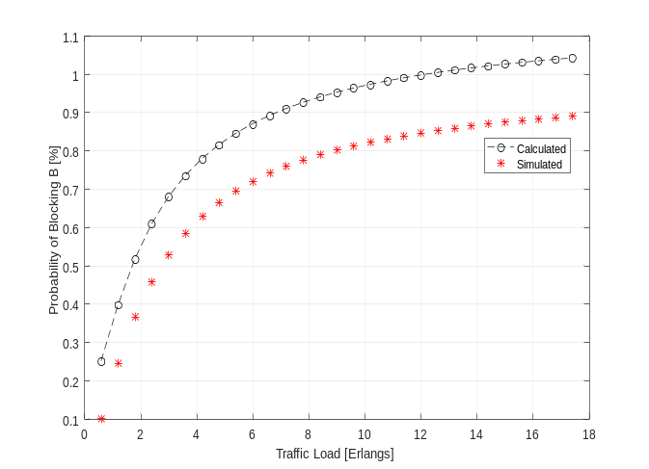
Fig. 5. Comparison of calculation and simulation results for 1st
Round

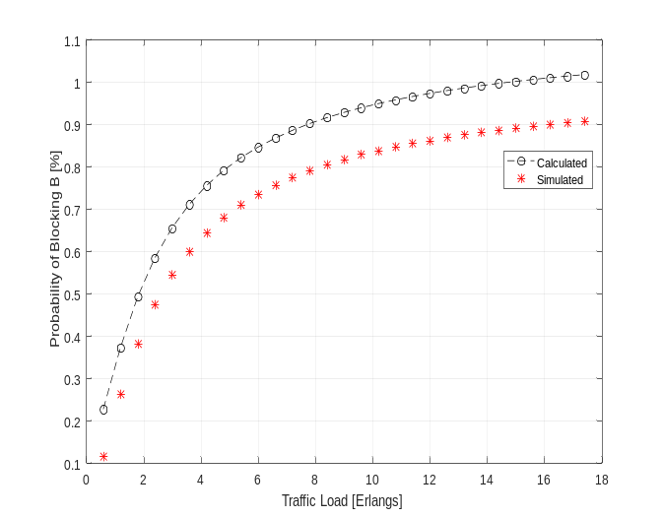
Fig. 6. Comparison of calculation and simulation results for 2nd
round

Conclusion
The paper proposes the idea of utilization of Erlang B and Erlang C formulas for description of traffic in IP data networks. All obtained results suggest the possibility of the Erlang formulas in data traffic. Erlang B formula does not contain parameter for probability of delay, therefore this formula is more suitable for ATM networks, because the probability of delay in this network is omissible. Through the Erlang C formula is possible to estimate the probability of delay, which usually occurs in IP networks. Description of traffic gives the opportunities to monitor the Grade of Service (GoS). It seems that simplicity of Erlang formulas can be their strong advantage against other methods for traffic description in asynchronous networks, but the more future research is necessary in this field.

References
- Klika O. Theory and experience of operation load in telecommunications. Praha, 1973, OS-31-047-73.
- ] Cooper R. B. Introduction to Queueing Theory. 2nd Edition, Elsevier, 1980, ISBN 0444010653.
- Cooper R. B. Introduction to Queueing Theory. 2nd Edition, Elsevier, 1980, ISBN 0444010653.
- Chromy, Erik, Tibor Misuth, and Adam Weber. "Application of Erlang Formulae in Next Generation Networks." International Journal of Computer Network and Information Security 4.1 (2012).

.

